Checkpoint:Git & GitHub Project

Screenshot 1

Created a folder named learn_git and navigated into it using the terminal.

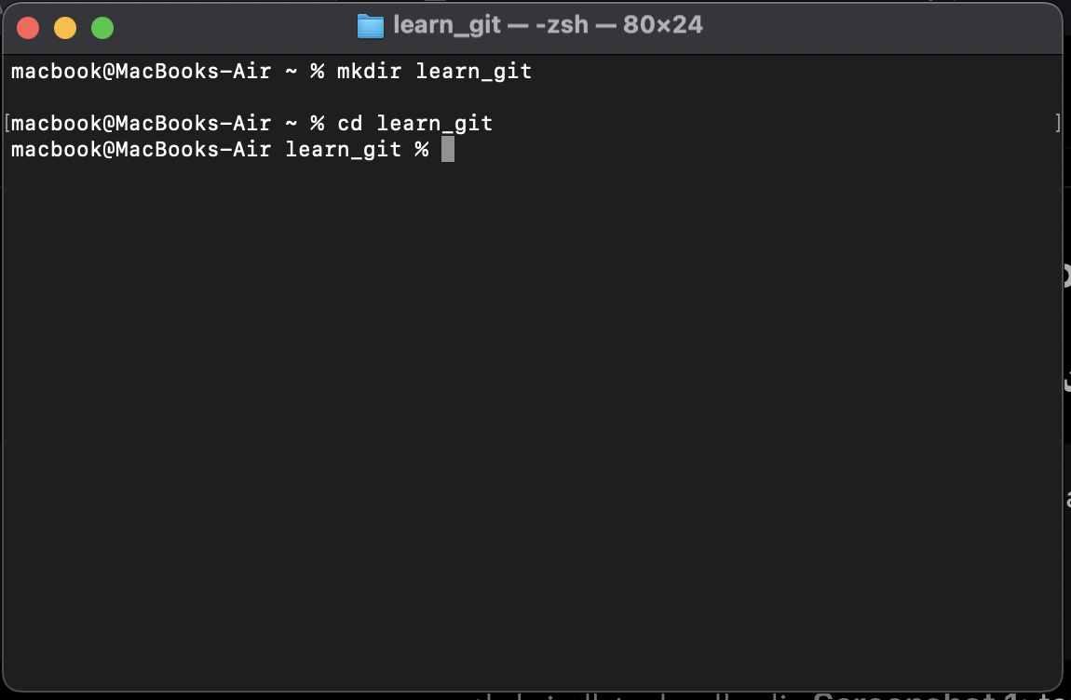

Screenshot 2

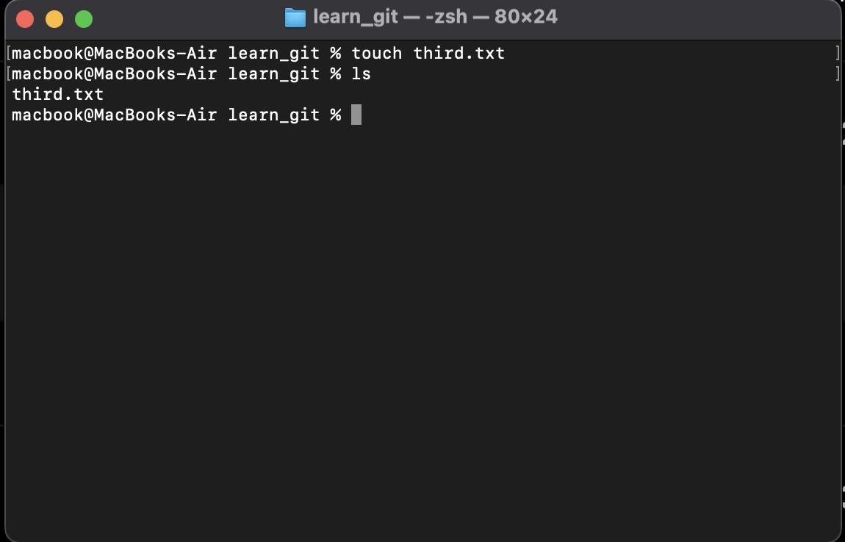
Created a file named third.txt inside the learn_git directory.

Screenshot 3

Initialized an empty Git repository using git init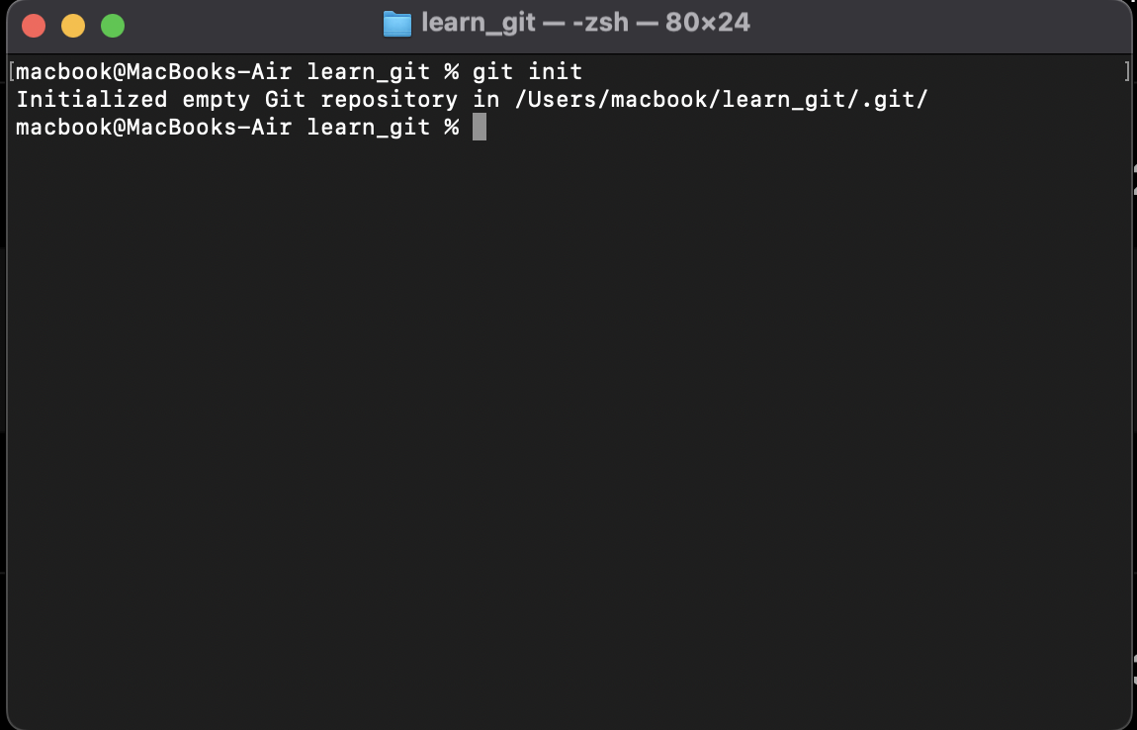.

Screenshot 4

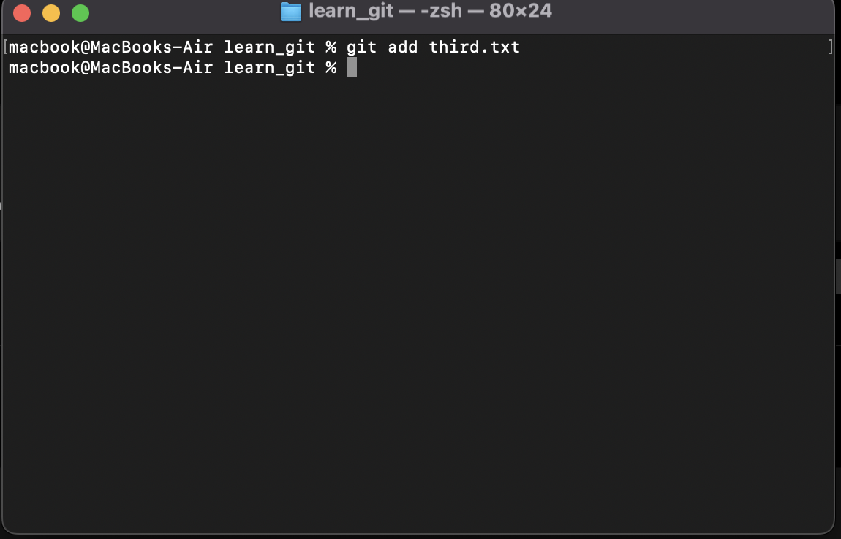
Added third.txt to the staging area using git add third.txt.

Screenshot 5

Committed changes with message "adding third.txt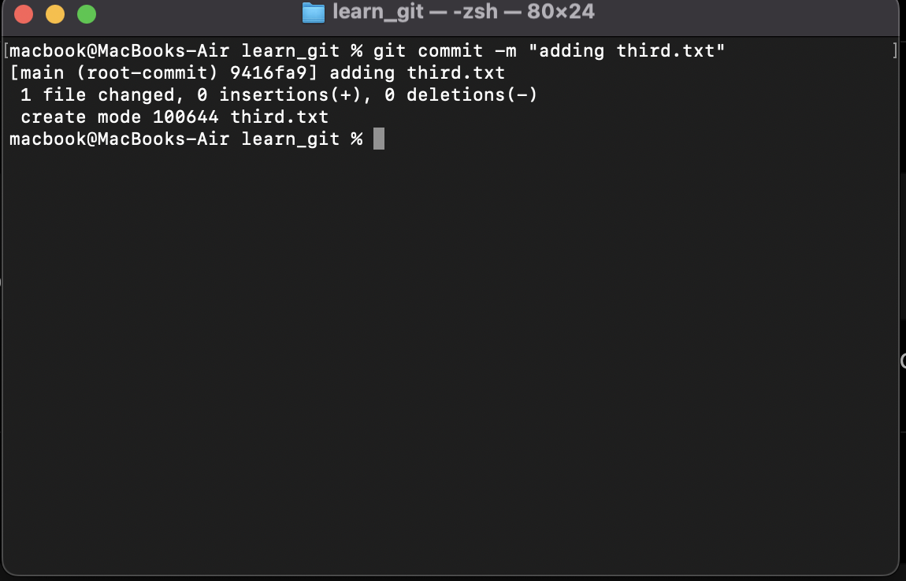".

Screenshot 6

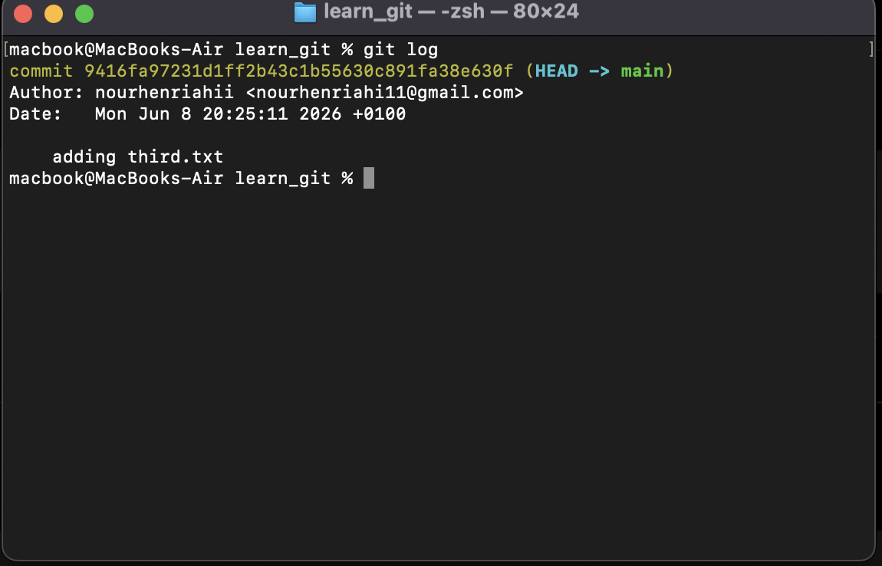
Displayed commit history using git log.

Screenshot 7

Created a new file named fourth.txt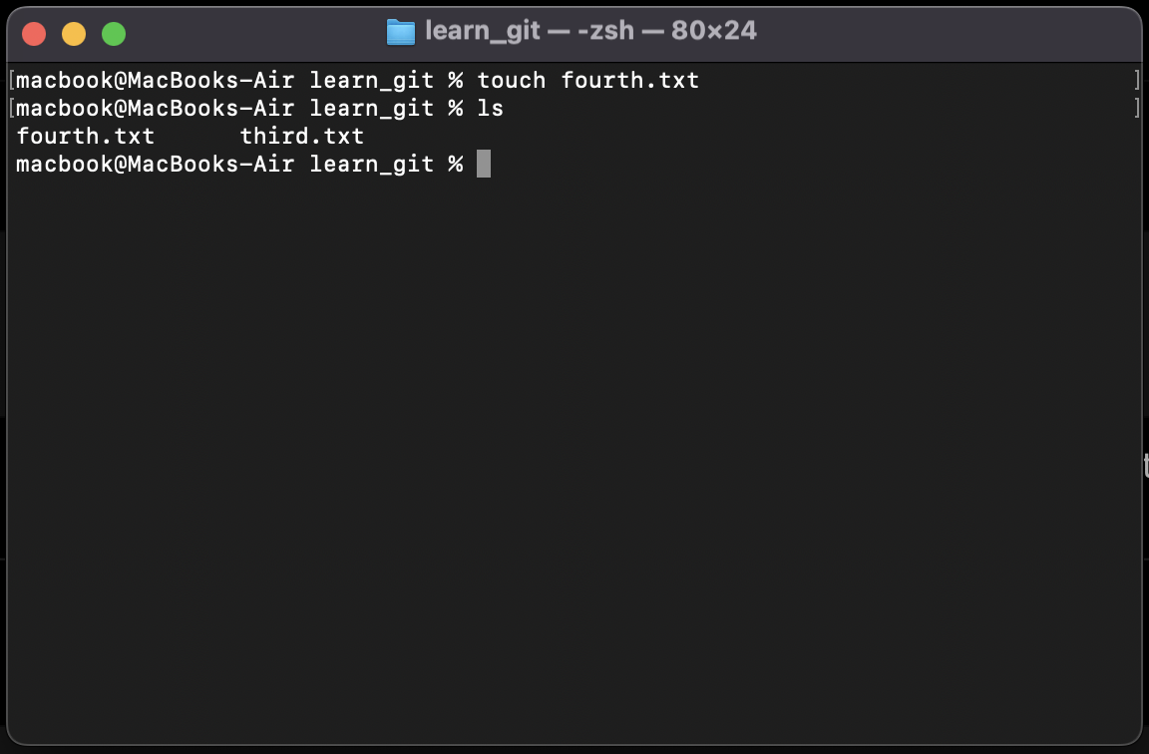.

Screenshot 8

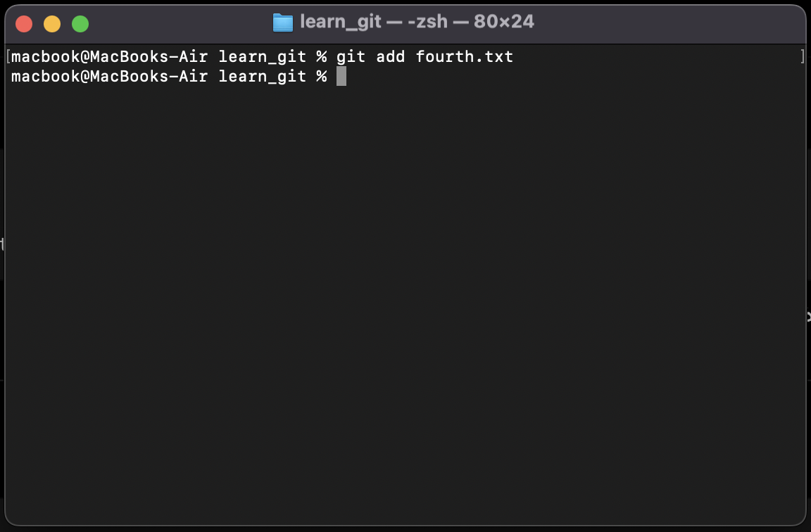
Added fourth.txt to the staging area.

Screenshot 9

Committed changes with message "adding fourth.txt".

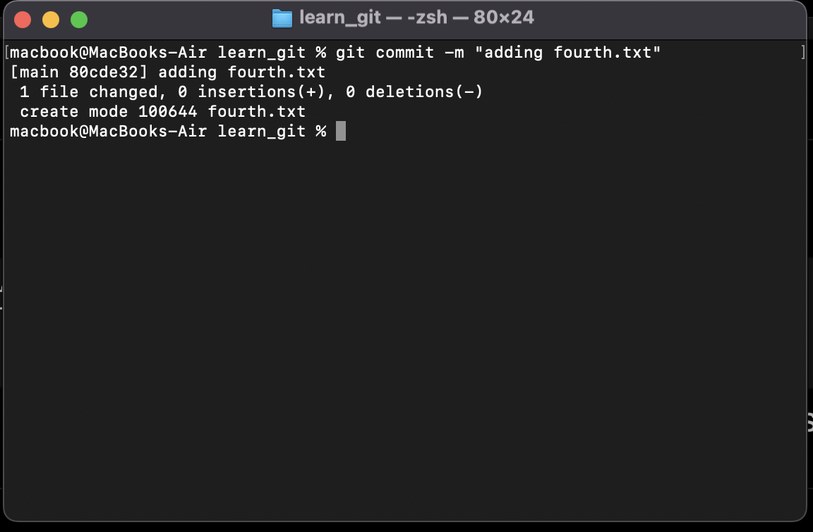

Screenshot 10

Deleted the file third.txt from the working directory.
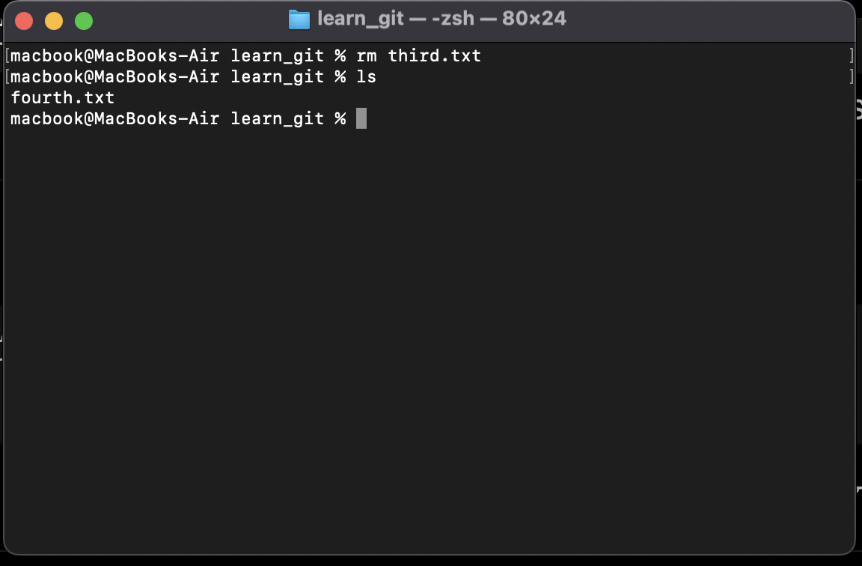

Screenshot 11

Added all changes (including deletion) using git add .

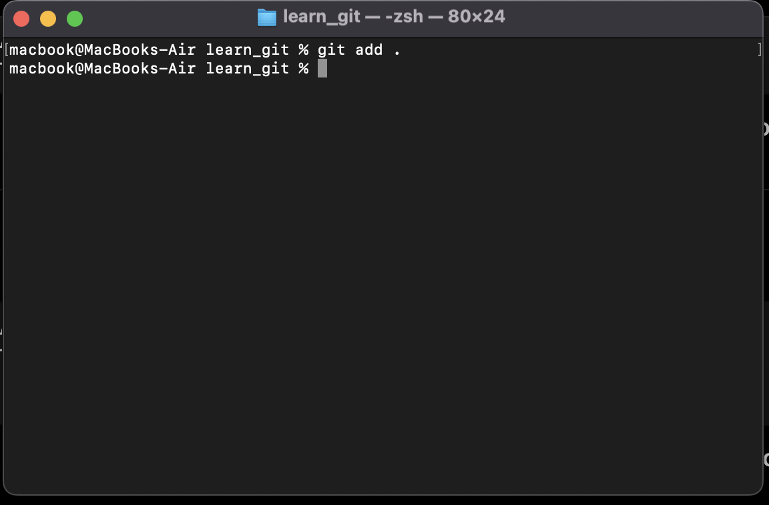

Screenshot 12

Committed changes with message "removing third.txt".
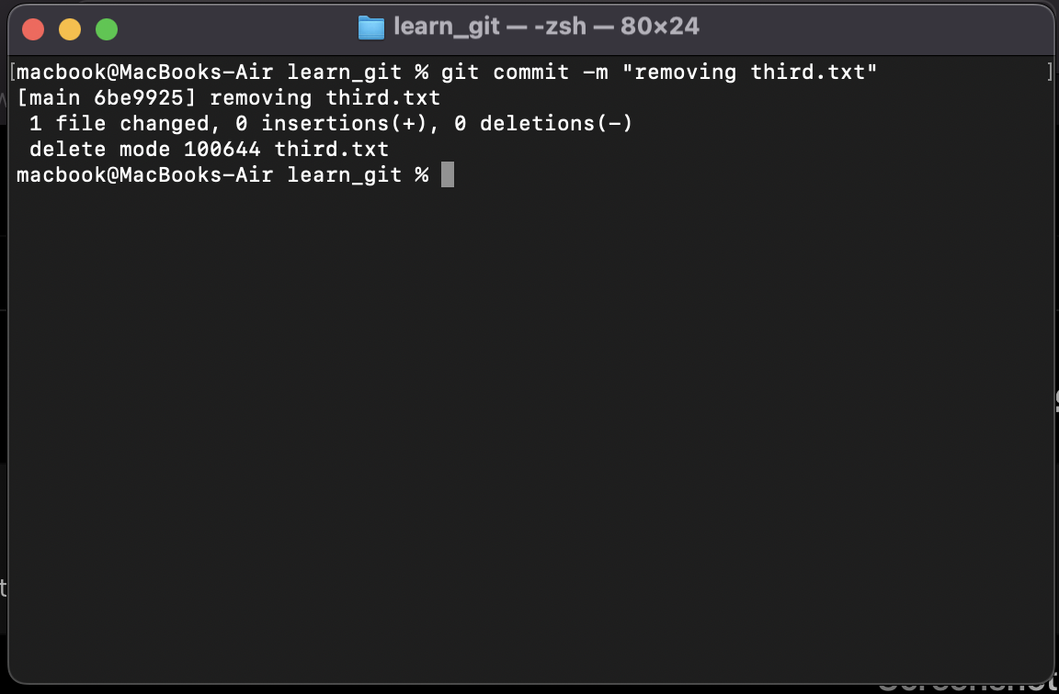

Screenshot 13

Displayed full commit history using git log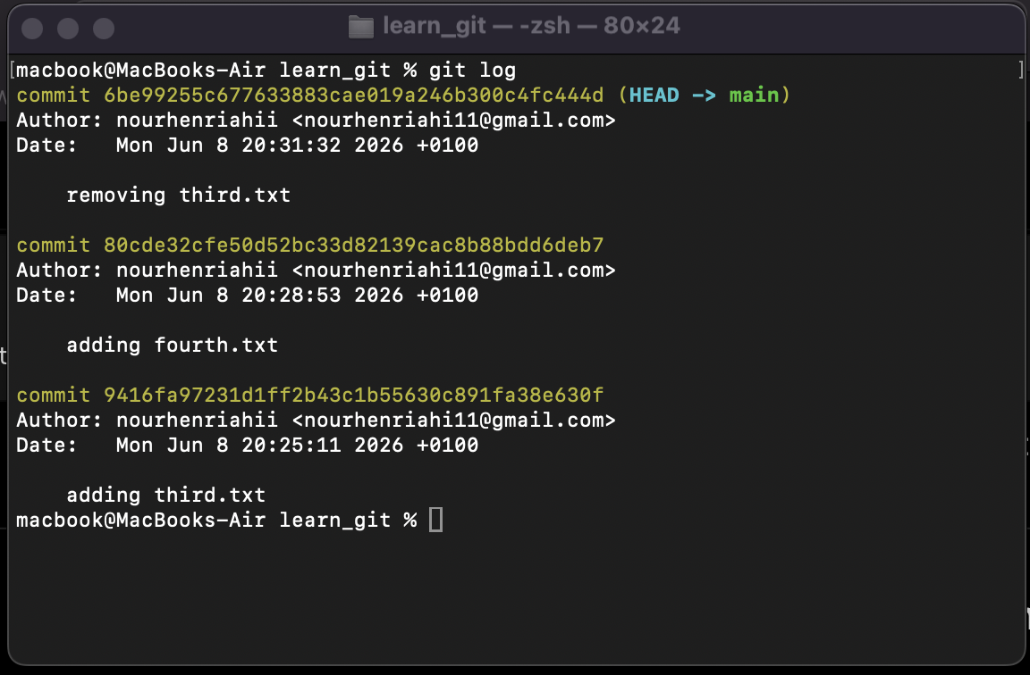.

Screenshot 14

Changed global Git setting core.pager to cat using:
git config --global core.pager "cat"
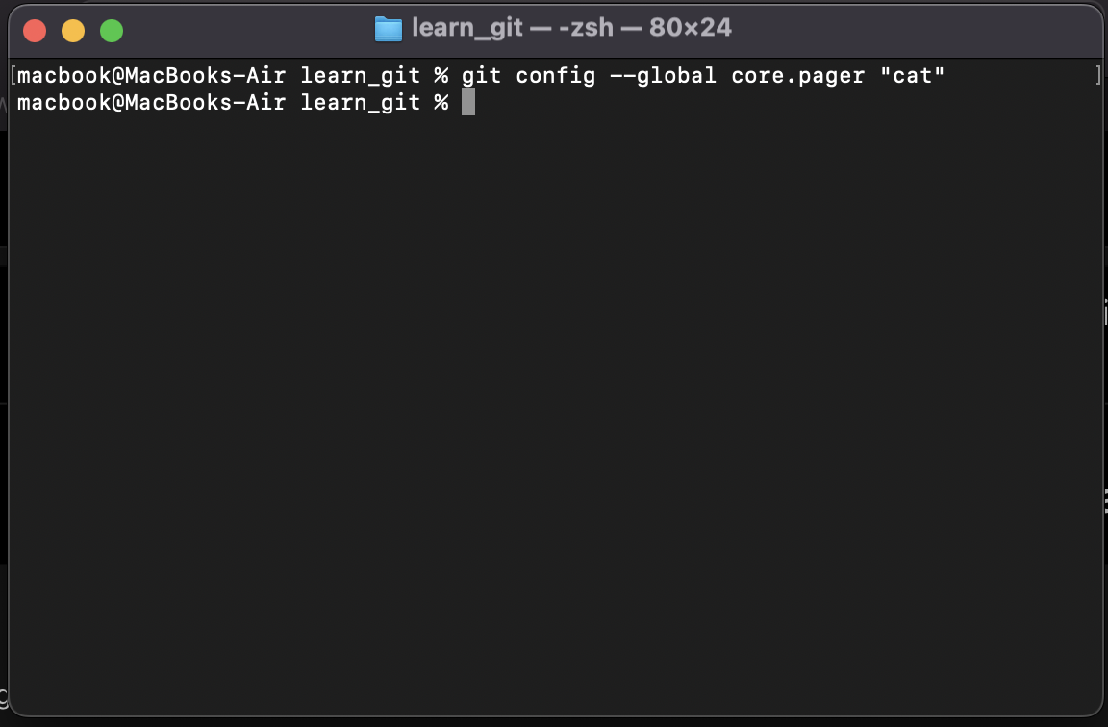

Screenshot 15

Displayed all global Git configurations using git config --global --list.
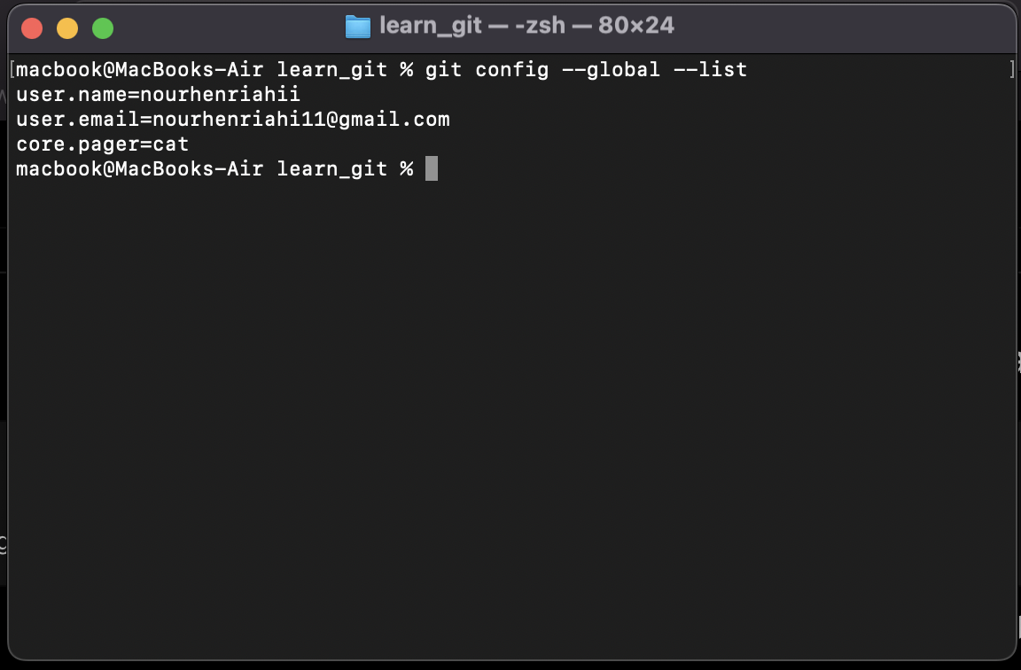

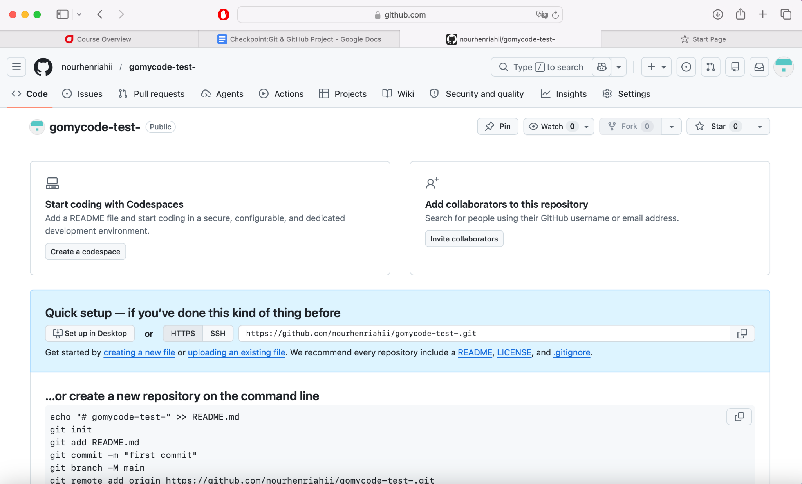
Screenshot 16:

Screenshot 17: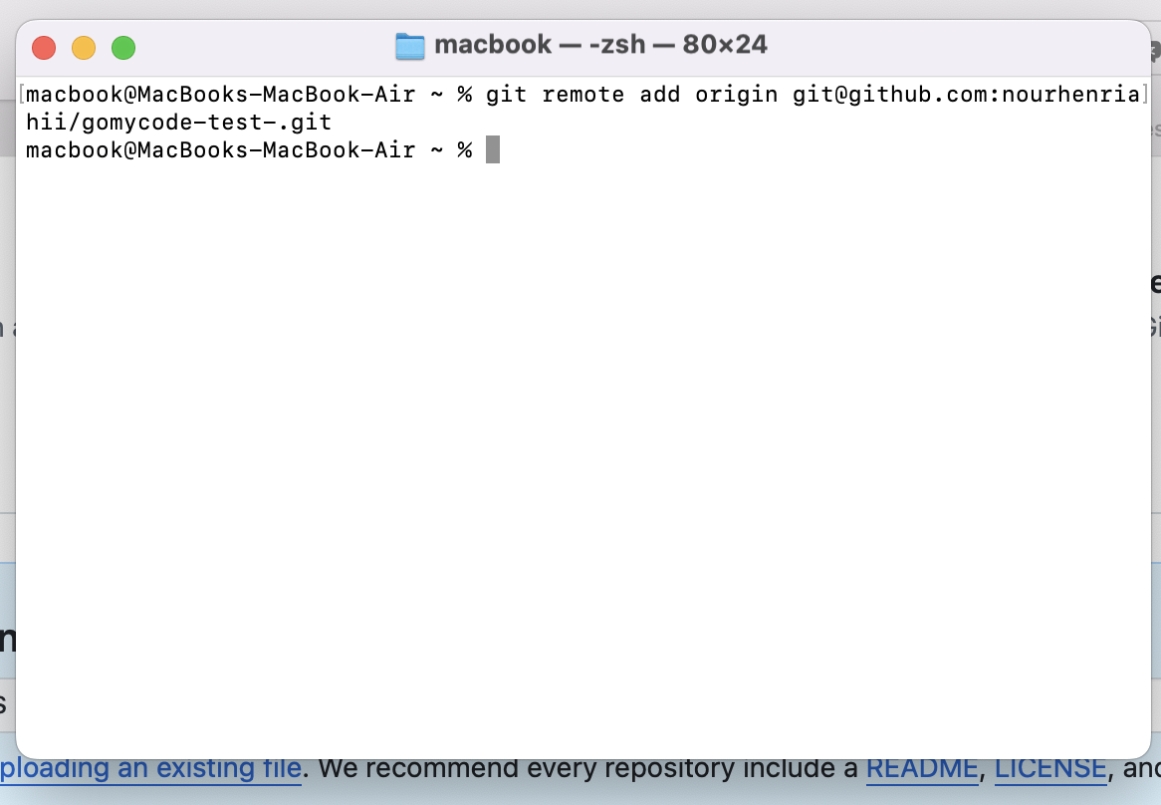

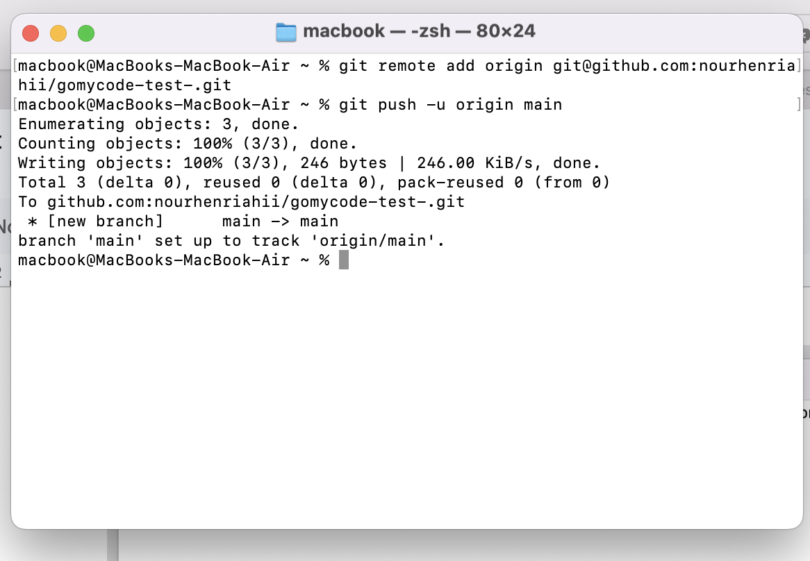
Screenshot 18:

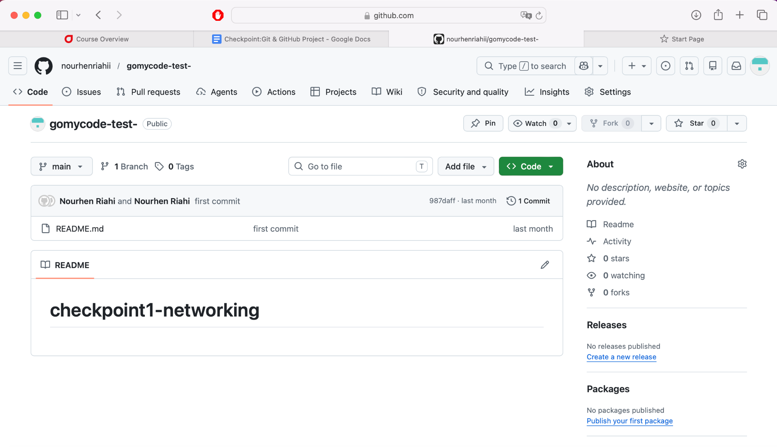
Screenshot 18:

